**APPENDIX 1**

**ONLINE PIZZA ORDERING SYSTEM**

END TERM REPORT

***by***

**RAVI, TENZIN AND SAI DINESH**

(Section: K19NSB)

(Roll Number(s): 57,58,59 )



**Department of Intelligent Systems**

**School of Computer Science Engineering**

**Lovely Professional University, Jalandhar**

**April-2020**

**APPENIX 2**

**Student Declaration**

This is to declare that this report has been written by us. No part of the report is copied from other sources. All information included from other sources have been duly acknowledged. We aver that if any part of the report is found to be copied, I/we are shall take full responsibility for it.

Kuna Ravi Sai Teja

Roll number: 57

Tenzin Wangmo

Roll number: 58

Puppala Sai Dinesh Kumar

Roll number: 59

Place : Lovely Professional University

Date : 1st April, 2020

**APPENDIX 3**

**TABLE OF CONTENTS**

**ONLINE PIZZA ORDERING SYSTEM PAGE NO.**

Introduction 5

Abstract 6

Objective 7

Description 8-9

Advantages/Disadvantages 10

Screenshots 11-13

SWOT Analysis 14

Work Division 15-16

Bibliography 17

**APPENDIX 4**

**BONAFIDE CERTIFICATE**

Certified that this project report “ONLINE PIZZA ORDERING SYSTEM.” is the bonafide work of “RAVI, TENZIN AND SAI DINESH” who carried out the project work under my supervision.

Signature of the Supervisor

Name of supervisor

Academic Designation

ID of Supervisor

Department of Supervisor

Introduction of the project Online Pizza Ordering System:

The “Online Pizza Ordering System” has been developed to override the problems prevailing in the practicing manual system. This software is to efficiently order the pizza eliminating the hardships of physically going to restaurant itself. Moreover this system is designed for the particular need of the company to carry out operations in a smooth and effective manner.

The website has made sure to avoid errors while entering and submitting the data. It also provides message if data is not submitted as per given information, thus by all means it is a user-friendly. Not only user-friendly, this project can lead to error free, secure, reliable and fast management system. It is also an attractive website from a customer point of view by the way which is a upper hand as most of the customer tends to drool over the pictures of those delicious pizza. It can also assist the user to concentrate on their other activities rather to concentrate on the record keeping. But on the other hand, the record keeping pages are very compatible to the user.

Any Organization, whether big or small, has challenges to overcome and managing the information of category, Food Items, Order, Delivery, and Customer. Every Online Pizza Ordering system has different Pizza Items needs and has different things to offer to the customer. This is designed to ensure that, it is equipped with the right level of information and detail for your future goals.

**Abstract**

The purpose of Online Pizza Ordering System is to automate the existing manual system by the help of computerized equipments and full-fledged computer software, fulfilling their requirements, so that their valuable data/information can be stored for a longer period with easy accessing and manipulation of the same. The required software and hardware are easily available and easy to work with.

Online pizza Ordering System, as described above, can lead to error free, secure, reliable and fast management system. It can assist the user to concentrate on their other activities rather to concentrate on the record keeping. Thus, it will help organization in better utilization of resources. It can maintain computerized records without redundant entries. That means that one need not be distracted by information that is not relevant, while being able to reach the information.

The aim is to automate its existing manual system by the help of computerized equipments and full-fledged computer software, fulfilling their requirements, so that their valuable information can be stored for a longer period with easy accessing and manipulation of the same. Basically the project describes how to manage for good performances and better service for the clients.

**Objective of the project:**

The main objective of the project on Online Pizza Ordering System is to manage the details of Pizza Items, Category, Cart, Orders. It manages all the information about pizza Item, Delivery, Customer, Category. The project is totally built at administrative end and thus only the administrator is guaranteed the access.

The main purpose of the project is to build a program to reduce the manual work. It tracks all the details about the customer.

**DESCRIPTION**

The **Online pizza order system** provides help to the customer who are interested in ordering pizza. There are EIGHT modules in this website :

**Home:**

Home is a complete, featured-packed to view all the necessary modules.

**Pizza Type( Shop Now):**

It is the section where you can explore all kinds of pizza, ranging different kinds of pizza Non-veg to Vegetarian and one can also order different sides like dessert to eat with your pizza and a cold drink never goes wrong with a pizza. All these items are available under the explore menu category.

**Cart:**

A cart is a piece of software that facilitates the purchase of pizza. It accepts the customers’ payment and organizes the distribution of that information to the merchant, payment processor and other parties. It bridge the gap between shopping and buying.

It stores product information. Its a gateway for order, catalog and customer management. It renders product data, categories and site information for user display.

**Contact Us:**

Through the contact session customers can communicate with the pizza company admin panel if they are facing any problem regarding any kind of issues. They can either call them or talk with the attending executives or mail them on the given email address.

**Location:**

This session consists of all your addresses. Your home addresses, alternative addresses. One can either fill their own address to which they want their pizza to be delivered or else your IP address identifies you on the internet. Thesedays, it’s likely that your computer shares an IP address with the other networked devices in your house or office. From your IP address, website can determine your rough geographical location.

OR nowadays many people use their GPS in their respective devices to trace their location easily without even mentioning it. That way the pizza executive trace your location and delivers your pizza.

**Offer Zone:**

In this section, one will receive extraordinary offers in some festive seasons and if you are lucky enough, you tend to get some great deal of coupons under some Terms and condition applied.

For that we need to insert the necessary data/information of the customer and make sure to press the submit button.

**About us:**

In this section, it gives you a rough idea about the pizza company that you are surfing.

It provides information about their pizza company regarding their financials , their marketing ideas, their featured articles.

ADVANTAGES:

-It overcomes all the problems of existing system.

-Pizza can be order in more convenient way.

-Payment can be easily done using various online mode or cash on delivery(COD).

-It makes system very effective for ordering a pizza.

-Easy update process of pizza.

DISADVANTAGE:

-It requires reliable internet connection.

-System may provide inaccurate results if data not entered correctly.

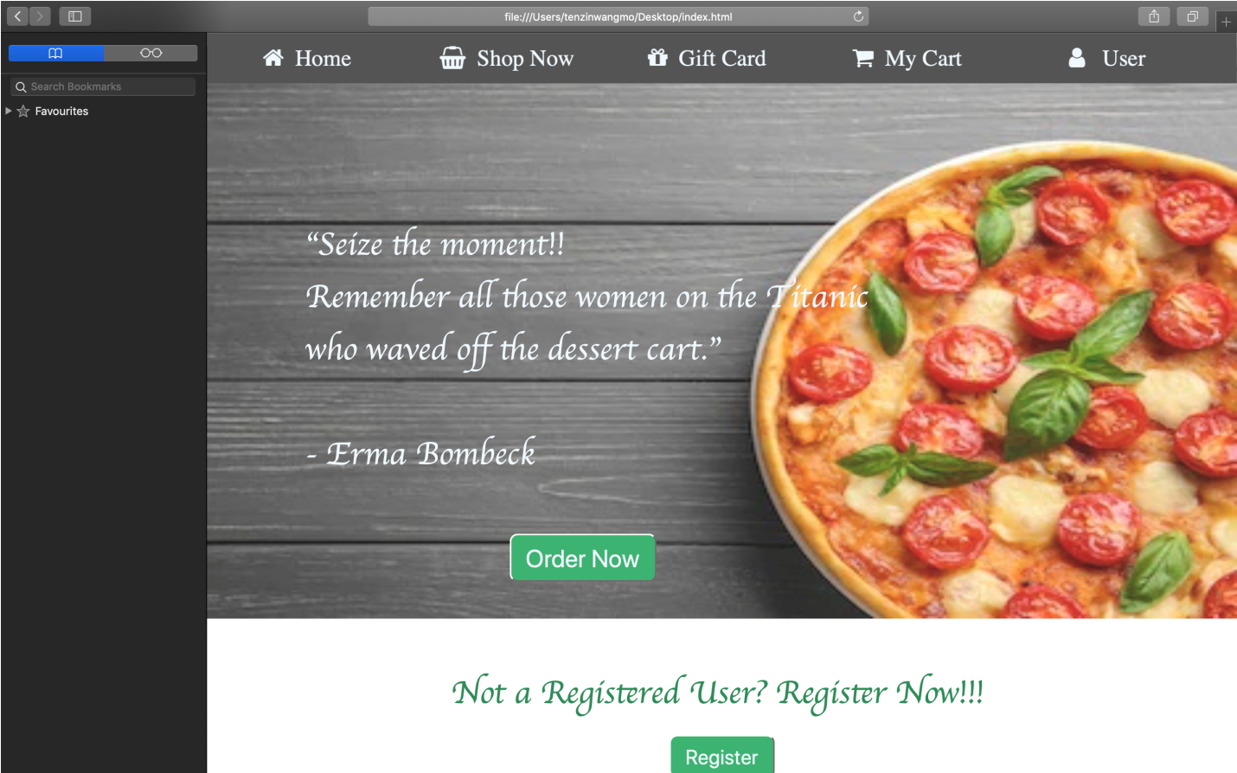

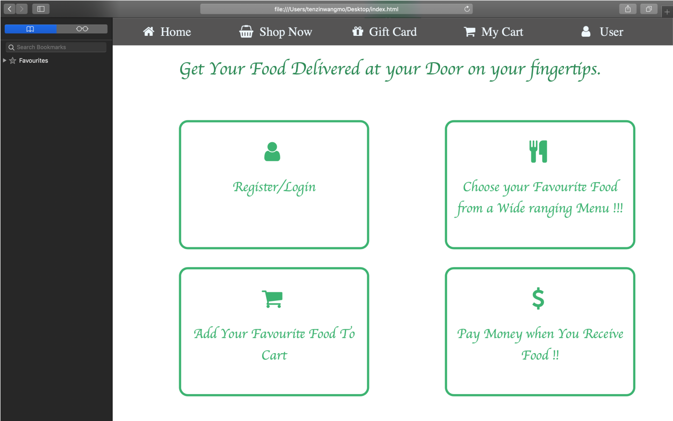

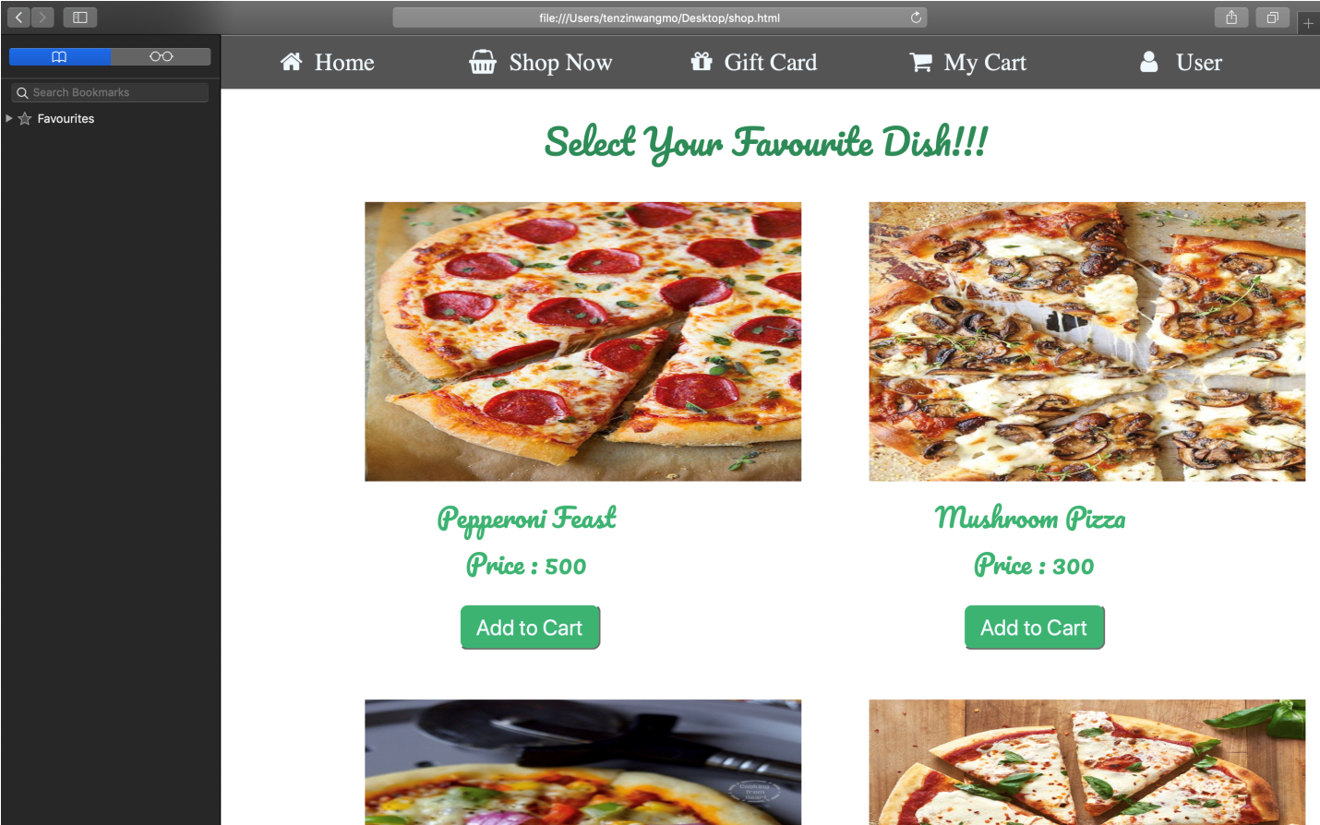

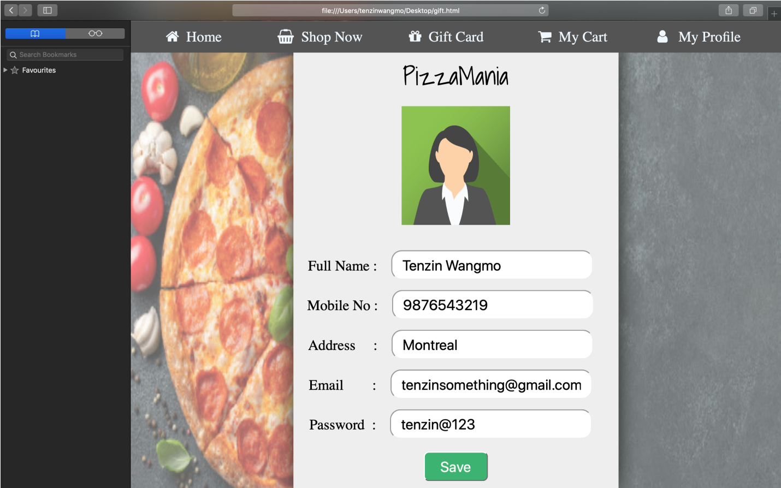

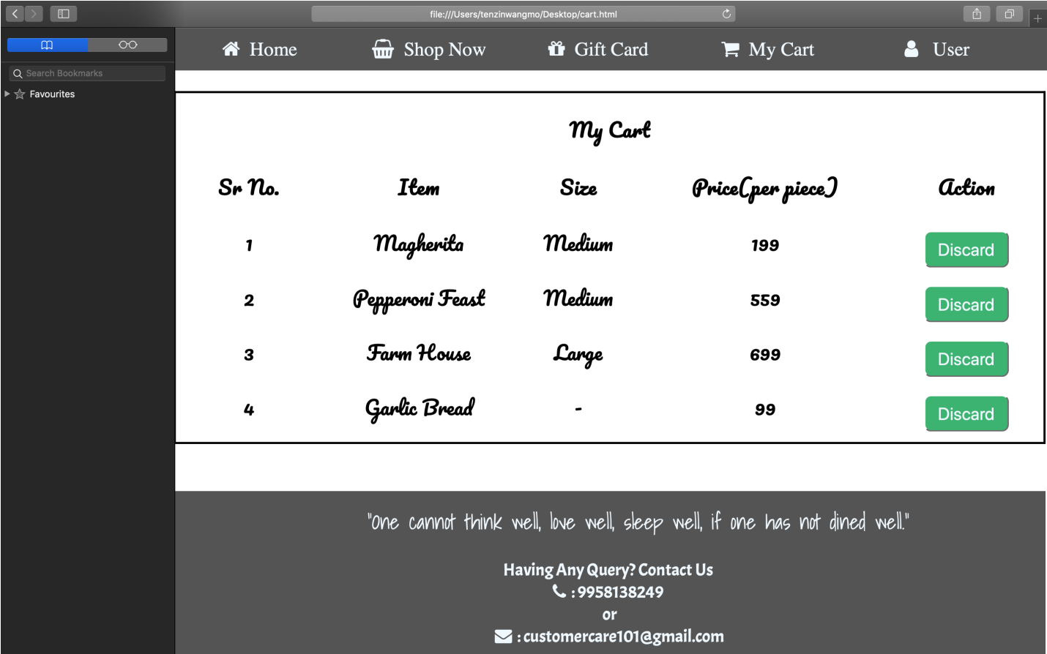

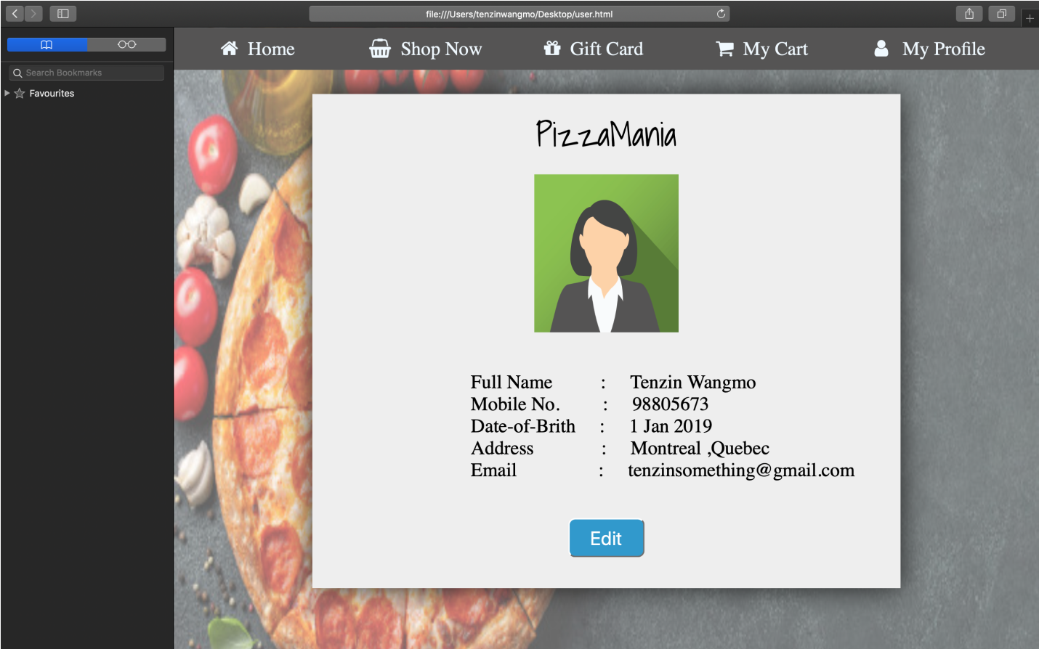

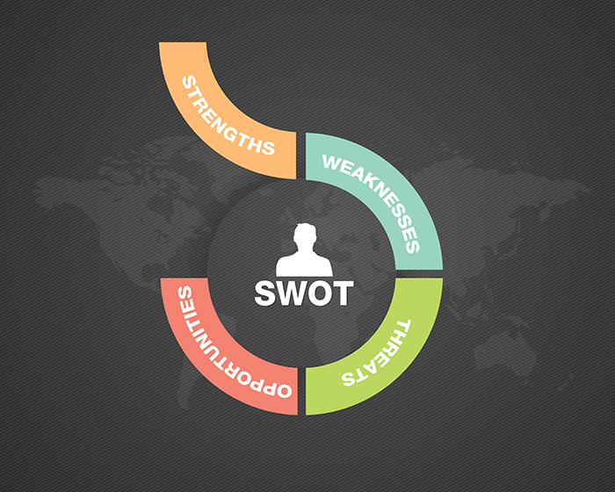

**SWOT ANALYSIS-**

Strengths

* Simple and easy to access.

Weakness

* Cannot track location.
* Prone to cyber hacks.
* Risk of computer viruses.

Opportunities

* Increasing Demand.
* Provides timely access.

Threats

* Better Quality provision from other providers.

**WORK DIVISION:**

**Requirement analyst (Ravi Sai Teja Roll no-57)**

The main task of his is to analyze the project and break it into smaller comprehensive components. In other words, he prepares ground for the website development. He gathers all the important tags that are very much vital in this project, hence playing an important role in this project. He gathers all the pictures that are related in making this project a success. He aids in making final project report.

**Project manager (Sai Dinesh Roll no-59)**

He is the conductor of our web development team. First he gets acquainted with all the technical specifications and the due date. Based on the information that he drawn, we plan the project, divided into stages. He manages to aid in writing final project report and the synopsis with detail information.

**Web Developer (Tenzin Wangmo Roll no-58)**

I, Tenzin designed the website entitled Online pizza ordering system with the help of my two other teammates. Programmers play a crucial role in the web development but without the help from my fellow teammates, it won’t be possible. At first, I analyze the project requirements along with its target to see virtually created scenario of the website. Followed by creating a wireframe of the project. I have managed to develop both Front-end and Back-end, thus creating a simple yet sophisticated website.

**Bibliography**

Some of the information has been taken from the following source:

* <http://reusability.org/read/chapters/gibbons.doc>
* <http://reusability.org/read/chapters/wiley.doc>
* <https://elearningindustry.com/>
* [www.w3school.com](http://www.w3school.com)